**DBMS**

**PRACTICAL 7**

**EXCEPTION HANDLING**

1. ZERO DIVIDE

Pl/Sql block

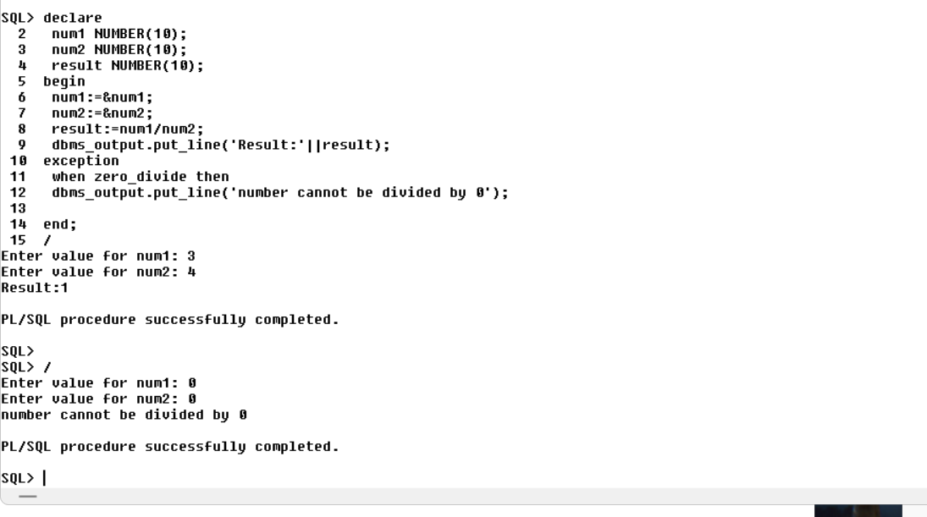

**Create table employee_5931:**

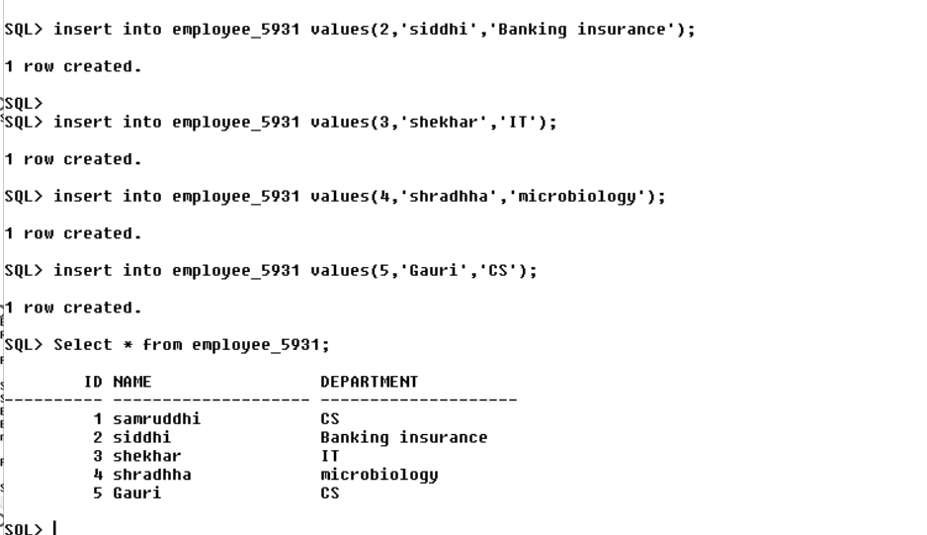

b) NO_DATA_FOUND

Pl/Sql block

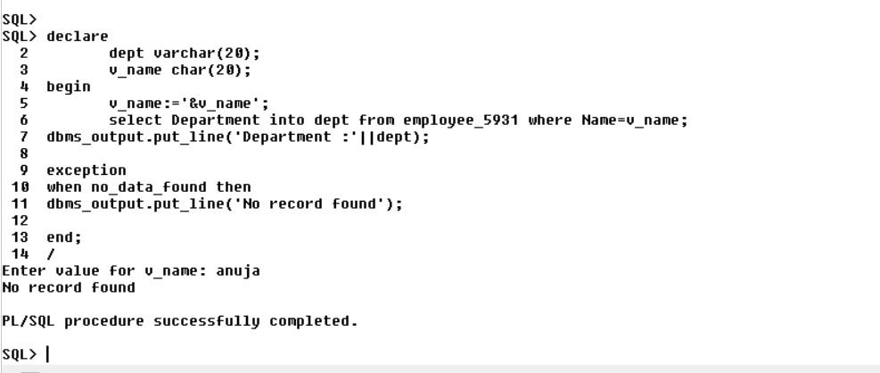

c) DUP_VAL_ON_INDEX

Pl/Sql block

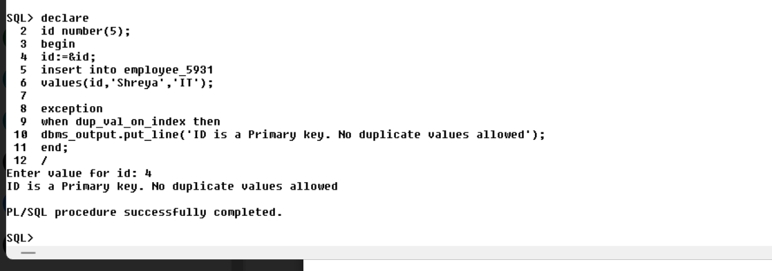

d) TOO_MANY_ROWS

Pl/Sql block

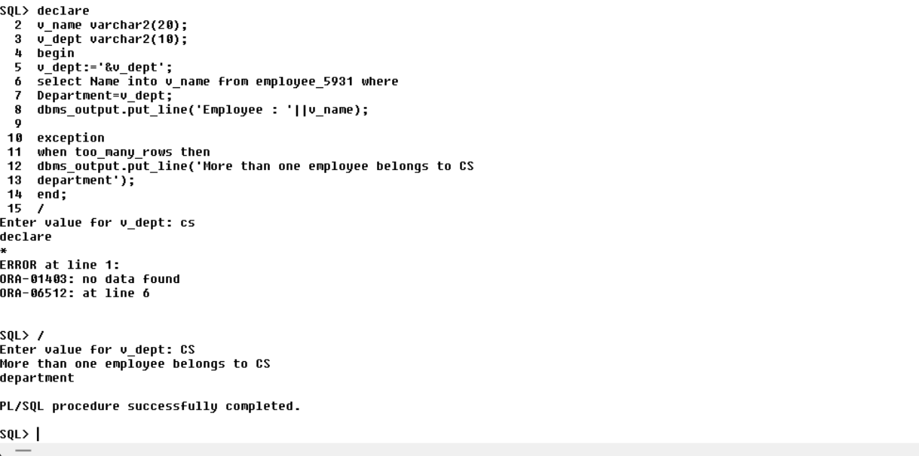

2) Write a PL/SQl block to handle user defined exception to check id should not be less than zero for searching by stud_id.

Pl/Sql block

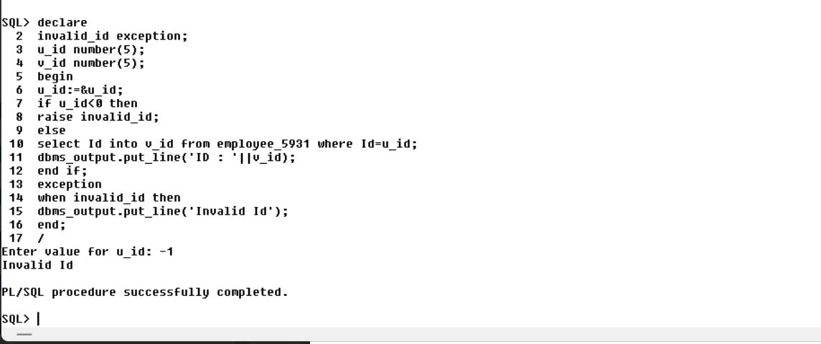

3) Write a PL/SQl block to handle exception by pragma and assign error code to exception

Create table empdetail

